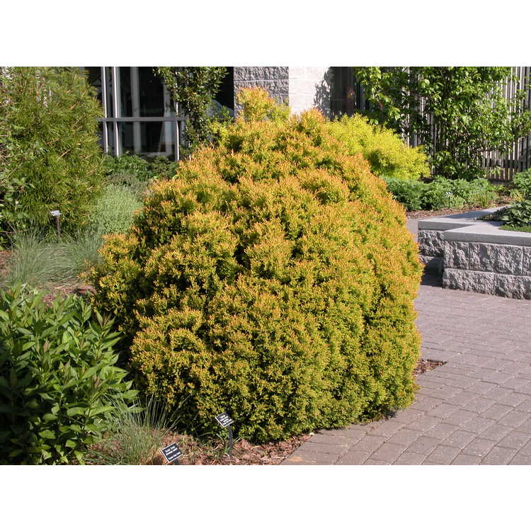

Rheingold Arborvitae Thuja occidentalis 'Rheingold'
- Here is a bright golden evergreen shrub that turns copper color in the winter.

- Great for boarders, around rocky areas, and as a low hedge. Shrub can be left natural or trimmed for formal look. Great for property divider without blocking views

- Prefers full sun, moderate soil, protect from winter winds, and will grow to 36” H by 36” wide in 10 years if left untrimmed.

- Classic arborvitae foliage; aka American or Eastern Arborvitae

