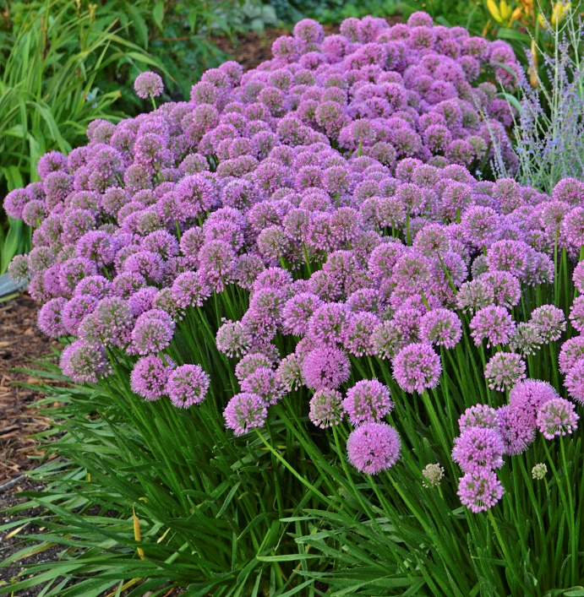

Photo by Walter’s Gardens Inc. Wild Juniper Nursery

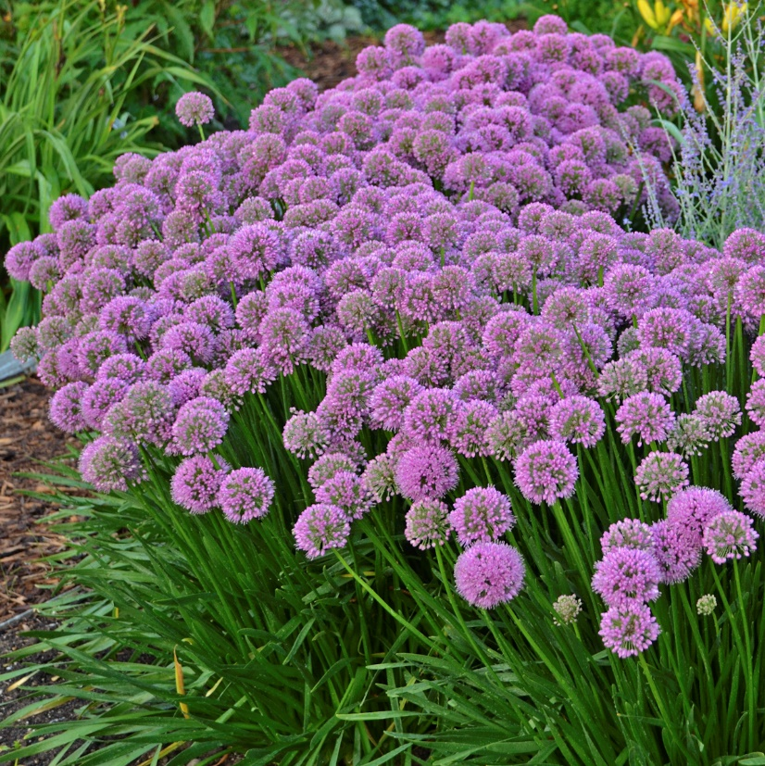
Photo by Walter’s Gardens Inc. Wild Juniper Nursery

Allium Ornamental Onion Allium 'Millenium
2018 Perennial of the Year!

- 18” H x 20” W; needs 4 hours of sun/day

- Needs only light watering will tolerate drought

- Blooms late July and August with an explosion of large 2 inch bright rosy purple blooms

- Attractive to honeybees and Butterflies

- Deer and Rabbit resistant due to oniony smell of crushed foliage.

- Forms a compact upright clump so easy to maintain.

Allium Ornamental Onion Allium 'Millenium
2018 Perennial of the Year!

- 18” H x 20” W; needs 4 hours of sun/day

- Needs only light watering will tolerate drought

- Blooms late July and August with an explosion of large 2 inch bright rosy purple blooms

- Attractive to honeybees and Butterflies

- Deer and Rabbit resistant due to slight oniony smell of crushed foliage.

- Forms a compact upright clump so easy to maintain.

