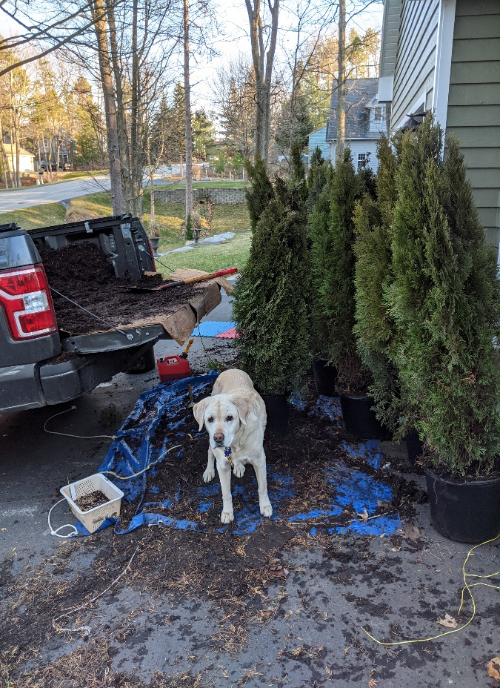

Emerald Green Arborvitae Thuja occidentalis 'Emerald Green'
- The perfect nosey neighbor screen!

- Plant 2’ to 3’ apart for screen at maturity for this narrow slow growing arb- grows less than 12” per year which produces a full looking thick screen

- Retains color year round

- Prefers partial sun but will grow in shade – water well 1st year until rooted

- New growth can be pruned - 10’ when mature

